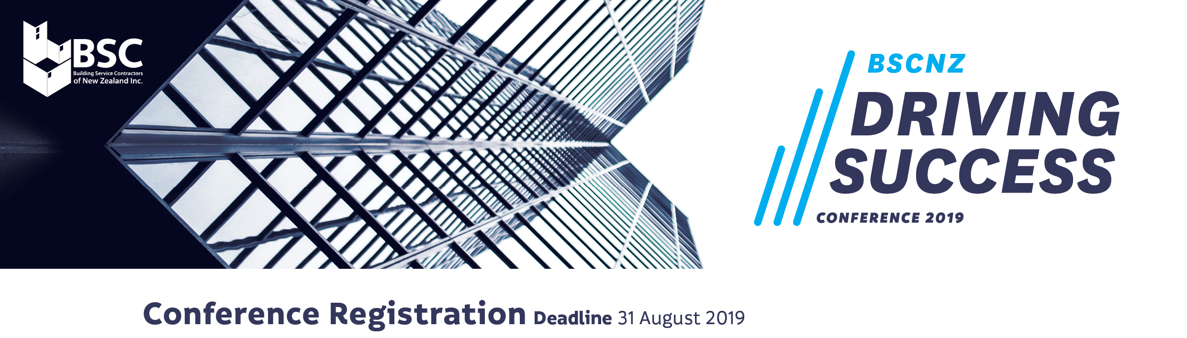

HOW TO FILL IN THIS FORM
- “Save As” a Word document and change the filename to include your Company name
before completing.
- Type text in boxes provided within the form and use TAB key to move to next field.
- Return your completed form to janine.fillet@bsc.org.nz no later than 31 August 2019.

COMPANY DETAILS
Name (First) (Last)
Organisation
Email
Postal address
Phone number

Email address for invoice

Purchase order number for invoice

Type of registration (cost per person – does not include accomodation)
BSCNZ Member Early Bird - $395+GST (available until 31 July 2019)
BSCNZ Member - $460+GST (from 1 August 2019)
Non-member Early Bird - $435+GST (available until 31 July 2019)
Non-member - $495+GST

PAYMENT INFORMATION
Refund or cancellation policy
Registrations cancelled less than 60 but more than 30 days before the conference will be at refunded 50% of the registration fees. Cancellations made less than 30 days before the conference will not be eligible for a refund. Please note: Non-advance payment of registration fees does not void the cancellation policy. All registrations not cancelled are still responsible for the full balance regardless of attendance. Cancellations must be submitted in writing to janine.fillet@bsc.org.nz
BSCNZ will generate an invoice which will be emailed to the address provided. Full payment must be received prior to the commencement of the conference.
Please note: Accommodation for the Hilton is to be booked directly with BSCNZ and paid for in advance.
Delegate Details Please complete the table below.

Name | Position | Email | Mobile | Attending dinner? | Dietary requirements | Accomodation  Required? | *$246 Single /  $274 Twin Share | Check In /  Check Out Date | Attending racing?
 |  |  |  | Y N |  | Y N | Single Twin | Check In Out | Y N
 |  |  |  | Y N |  | Y N | Single Twin | Check In Out | Y N
 |  |  |  | Y N |  | Y N | Single Twin | Check In Out | Y N
 |  |  |  | Y N |  | Y N | Single Twin | Check In Out | Y N
 |  |  |  | Y N |  | Y N | Single Twin | Check In Out | Y N
 |  |  |  | Y N |  | Y N | Single Twin | Check In Out | Y N
 |  |  |  | Y N |  | Y N | Single Twin | Check In Out | Y N
 |  |  |  | Y N |  | Y N | Single Twin | Check In Out | Y N
 |  |  |  | Y N |  | Y N | Single Twin | Check In Out | Y N
 |  |  |  | Y N |  | Y N | Single Twin | Check In Out | Y N
 |  |  |  | Y N |  | Y N | Single Twin | Check In Out | Y N
 |  |  |  | Y N |  | Y N | Single Twin | Check In Out | Y N
 |  |  |  | Y N |  | Y N | Single Twin | Check In Out | Y N
 |  |  |  | Y N |  | Y N | Single Twin | Check In Out | Y N
 |  |  |  | Y N |  | Y N | Single Twin | Check In Out | Y N
 |  |  |  | Y N |  | Y N | Single Twin | Check In Out | Y N
 |  |  |  | Y N |  | Y N | Single Twin | Check In Out | Y N
 |  |  |  | Y N |  | Y N | Single Twin | Check In Out | Y N
 |  |  |  | Y N |  | Y N | Single Twin | Check In Out | Y N

Thank you for your registration
Please contact Sarah McBride CEO BSCNZ if you have any questions: E-mail: Sarah.McBride@bsc.org.nz | Phone: +64 21 577 812

